Unit 3 questions

Deadline: by the class on Thursday (September 18th)

Instructions:
- Answer all questions in this file and upload it back.
- You may use any materials and tools.
- Give brief and clear justification.
- Total: 10 points

Enjoy!

- (1 point) Question 3.3 Choose the correct answer(s)
Based on the information in Figure 3.3, read the following statements and choose the correct option(s).
- 1.Karim will always choose to work 16 hours because doing so maximizes his total income.
- 2.If Karim’s maximum working hours per day increased by two hours, under the same hourly wage, his maximum income would be €540.
- 3.If Karim had ten hours of free time per day and spent the rest of his time working, his daily income would be €300.
- 4.If Karim’s hourly wage were instead €20, the slope of the line relating his income to working hours would be less steep than that shown in Figure 3.3.
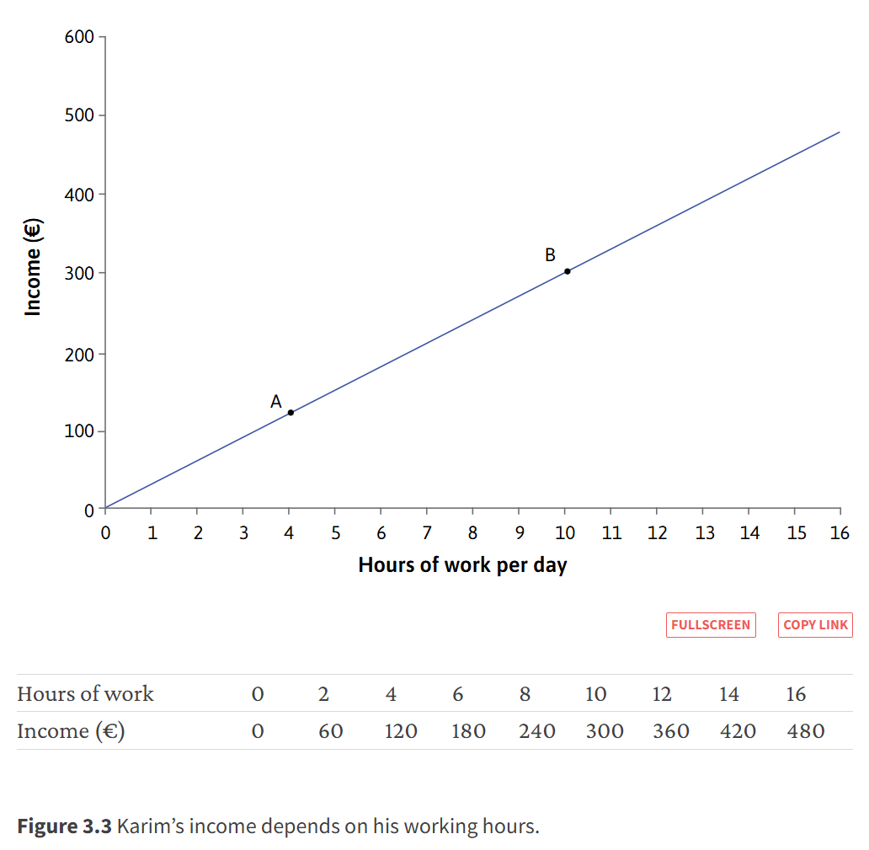
- (2 points) Exercise 3.1 Why Indifference Curves Never Cross
In this diagram, IC₁ is an indifference curve joining all the combinations that give the same level of utility as A. Combination B is not on IC₁.
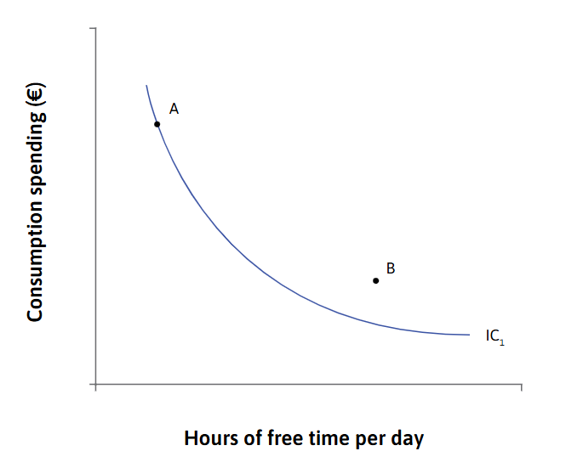
- Does combination B give higher or lower utility than combination A? How do you know?
- Draw a sketch of the diagram, and add another indifference curve, IC₂, that goes through B and crosses IC₁. Label the point at which they cross as C.
- Combinations B and C are both on IC₂. What does that imply about their levels of utility?
- Combinations C and A are both on IC₁. What does that imply about their levels of utility?
- According to your answers to 3 and 4, how do the levels of utility at combinations A and B compare?
- Now compare your answers to 1 and 5, and explain how you know that indifference curves can never cross.
Please write your answer here…

(2 points) Exercise 3.2: Your marginal rate of substitution
Imagine that you are offered a job at the end of your university course with a salary per hour (after taxes) of £12.50. Your future employer then says that you will work for 40 hours per week, leaving you with 128 hours of free time per week. You tell a friend: ‘at that wage, 40 hours is exactly what I would like.’
- Draw a diagram with free time on the horizontal axis and weekly pay on the vertical axis, and plot the combination of hours and the wage corresponding to your job offer, calling it A. Assume you need about 10 hours a day for sleeping and eating, so you may want to draw the horizontal axis with 70 hours at the origin.
- Now draw an indifference curve so that A represents the hours you would have chosen yourself.
- Now imagine you were offered another job requiring 45 hours of work per week. Use the indifference curve you have drawn to estimate the level of weekly pay that would make you indifferent between this and the original offer.
- Do the same for another job requiring 35 hours of work per week. What level of weekly pay would make you indifferent between this and the original offer?
- Use your diagram to estimate your marginal rate of substitution between pay and free time at A.
Please write your answer here…

- (2 points) Exercise 3.3 A student budget problem
Zoë, a student planning her budget for her first term at university in London, has found out from a survey on a student website that in 2021, UK students spent an average of £88 per month on socializing and eating out: £47 on ‘going out’ and £41 on ‘takeaways and eating out’. With these numbers to guide her, she decides to set aside £240 for social activities and entertainment during the term. She estimates that a night out socializing with friends will cost £16 on average, but she also wants to be able to go to the cinema regularly, and cinema tickets cost £10 each.
- If Zoë used the whole budget for nights out, how many could she have?
- If she spent the whole budget on cinema tickets, how many could she buy?
- Complete the table below to show how many nights out Zoë could have if she decided to buy the number of cinema tickets shown. (Not all of the answers are whole numbers.)
- Use the information in the table to draw Zoe’s budget constraint, with cinema tickets on the horizontal axis and nights out on the vertical axis. What is the marginal rate of transformation?
Cinema tickets, c | 0 | 4 | 8 | 12 | 16 | 20 | 24
Nights out, n

Please write your answer here…

- (2 points) Exercise 3.5 Alexei’s constrained choice problem
Consider the situation of Alexei, a student, who knows that his final grade from the course will depend on the average number of hours he studies in a day. If he does not study, his grade will be zero. For each hour that he studies, his grade will increase by 8 percentage points, up to a maximum of 12 hours per day. After that, more study will not raise his grade any further.
- Suppose that the only things Alexei cares about are his final grade and his free time. Are these two goods scarce for Alexei? Explain.
- Draw a graph showing how Alexei’s grade depends on his hours of study (with study hours on the horizontal axis).
- In a diagram with hours of free time on the horizontal axis and grade on the vertical axis, sketch indifference curves to represent Alexei’s preferences, assuming as before that they are downward-sloping and become flatter as free time increases.
- Add Alexei’s feasible frontier and feasible set to the diagram. (Hint: it should be the mirror image of the graph in Question 2 of this exercise.) What is his marginal rate of transformation between free time and grade points?
- Mark Alexei’s preferred choice on your diagram. (Your answer will depend on how you have drawn the indifference curves). How many hours per day does he choose to study?
- Draw another set of indifference curves (using a separate diagram) to show that Alexei’s preferences could lead him to choose exactly 12 hours of free time per day, and that in this special case, his MRS could be less than his MRT. Would he ever decide to have fewer than 12 hours of free time?
Please write your answer here…

- (1 points) Exercise 3.6 Why do people still work long hours?
An article by Tim Harford in the Undercover Economist column of the Financial Times considers why we have not reduced working hours as much as Keynes expected.²
Tim Harford. 2015. ‘The rewards for working hard are too big for Keynes’s vision’. The Undercover Economist. First published by The Financial Times. Updated 3 August 2015. Close footnote
- What are the main reasons he suggests for this observation? Would these reasons affect some groups of workers more than others?
- If Tim Harford is right, what has happened to our marginal rate of substitution between consumption and free time as prosperity has increased?
Please write your answer here…

